Day 6 :

Web Service:
Giving the service for web application when both application running using different technologies or language. With help of web service we can make loosely couple between view and server side technology.
If we make express JS as rest full web service view can be any frontend technologies like angular or react or vue js or client js as well as any other programming language.

Server side view technologies are
JSP
Asp
Php
CGI
EJS
Pugs

If we use EJS as view engine then server side programming language must be Node with Express JS. Thes view engine are depends upon respective server side programming language. We can’t use JSP as view engine for node js and vice-versa.
Every view engine follow its own syntax.

Express JS View engine.

Req (Java Request) ----
App1 XML/JSON App2
Java Express JS
-Response (JS response)
HSBC SBI
XML : eXtensible markup up language
JSON : JavaScript Object Notation

Java or Python or JavaScript function or methods are present. They are consider as service.
SOAP Web Service : Simple Object Access Protocol : in SOAP Web Service we can consume and produce the data in xml format. SOAP web service base upon SOA (Service Oriented architecture). WSDL (Web Service Description language)
Rest Full Web Service : Representation State Transfer : In Rest Full web service we can consume and produce data in any format base upon client requirement like plain text, html, xml, json or any media type etc.
WADL file (Web Application Description language)
Rest full web service support all http protocol methods.
Get Get the resources of employee, customer in json format.
If we connect to db select query
Post to create the resource
If we connect to db insert query
Put/Patch to update existing resource
If we connect to db update query
Put is use to update all property of existing object using unique property
Patch is use to update partial property not all.
Delete to delete existing resource
If we connect to db delete query

Creating simple rest full web service to produce the data in different format with get method.

RestFullWeb Service - Root folder

mkdir rest-api-different-format-data
npm init -y
npm install express

creating rest api with in memory (array) for product
Get Method : get all product details in json format.
Search the product id
- Query param
URL?key=value
URL?key1=value1&key2=value2
URL?key1=value1&key2=value2&key3=value3
If client is normal form with get method. Because form with get method internally use query param technique.
- Path param
URL/value1
URL/value1/value2
Post method : store product data with product id must be unique

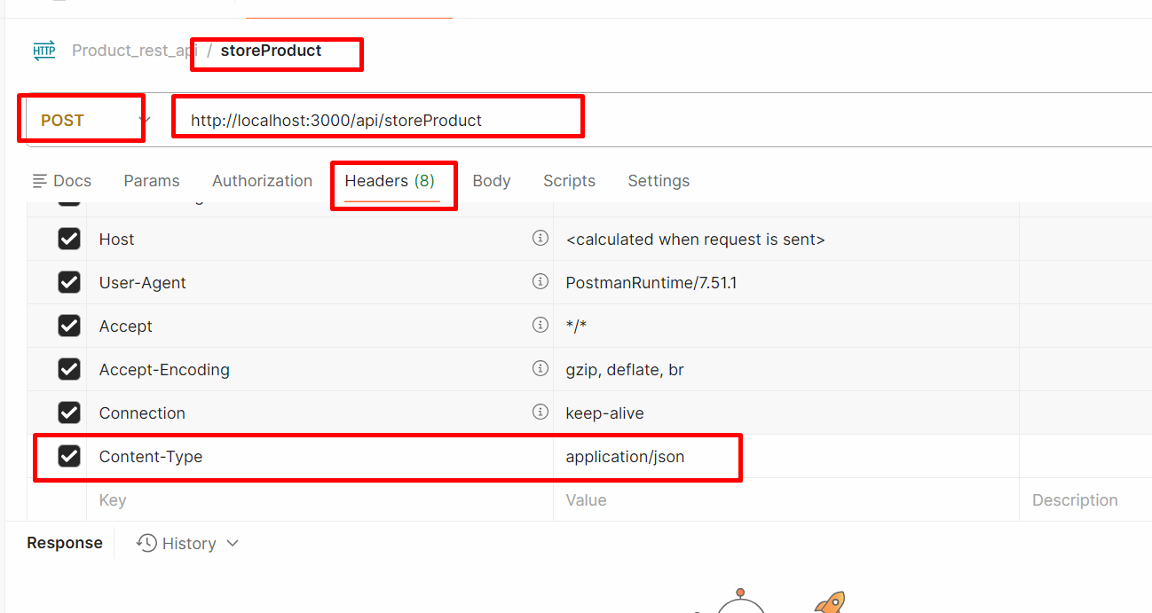
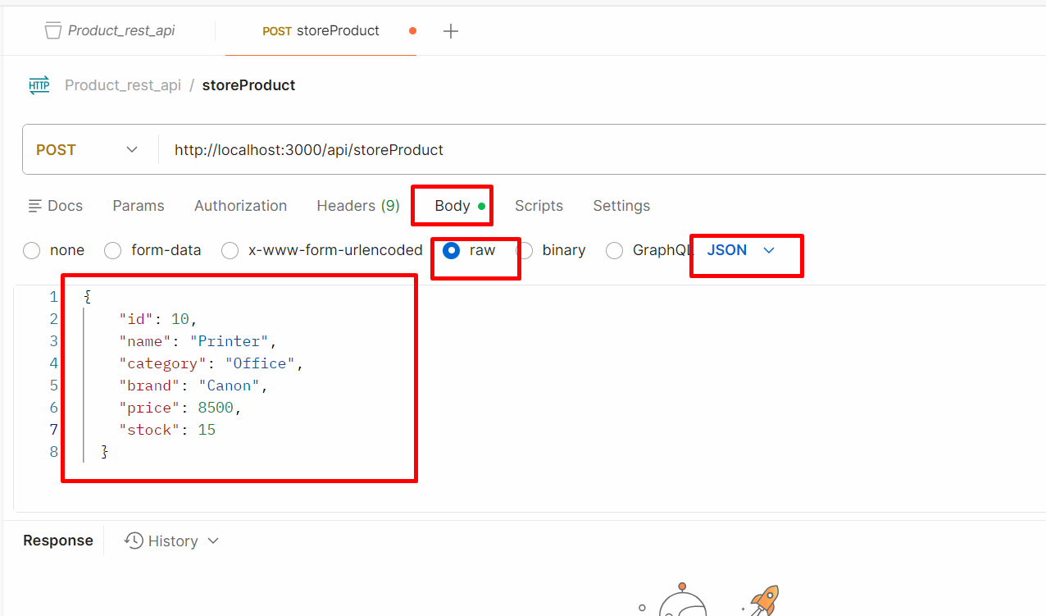

Put/Patch method : update product price
Delete method : delete the product using pid

Mkdir product-rest-api
Npm init -y
Npm install express

JSON : pre defined object in JS
JSON.stringify() : help to convert JS or JSON object into string format.
JSON.parse() : help to convert string to json object format.

